Hypertext Mark-up Language (HTML) is the standard mark-up for creating [web pages](https://en.wikipedia.org/wiki/Web_page) and [web applications](https://en.wikipedia.org/wiki/Web_application). With [Cascading Style Sheets](https://en.wikipedia.org/wiki/Cascading_Style_Sheets) (CSS) and [JavaScript](https://en.wikipedia.org/wiki/JavaScript), it forms a triad of [cornerstone](https://en.wikipedia.org/wiki/Cornerstone) technologies for the [World Wide Web](https://en.wikipedia.org/wiki/World_Wide_Web).[[4]](https://en.wikipedia.org/wiki/HTML#cite_note-4)

[Web browsers](https://en.wikipedia.org/wiki/Web_browser) receive HTML documents from a [web server](https://en.wikipedia.org/wiki/Web_server) or from local storage and [render](https://en.wikipedia.org/wiki/Browser_engine) the documents into multimedia web pages. HTML describes the structure of a web page [semantically](https://en.wikipedia.org/wiki/Semantic_Web) and originally included cues for the appearance of the document.

1. Design:

UNIQUE WEARS is a web site project with the main purpose to introduce UNIQUE WEARS footwear products. It has “Home” page and a navigation that links to other pages on the web site. UNIQUE WEARS’s web site has five responsive pages Home, Men, Ladies, Kids, About Us.

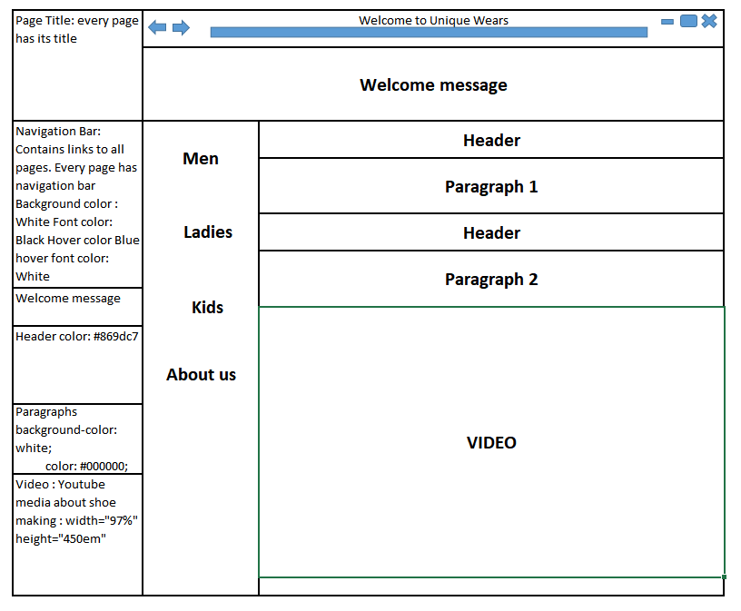Image 1: Home page sketch design for larger displays

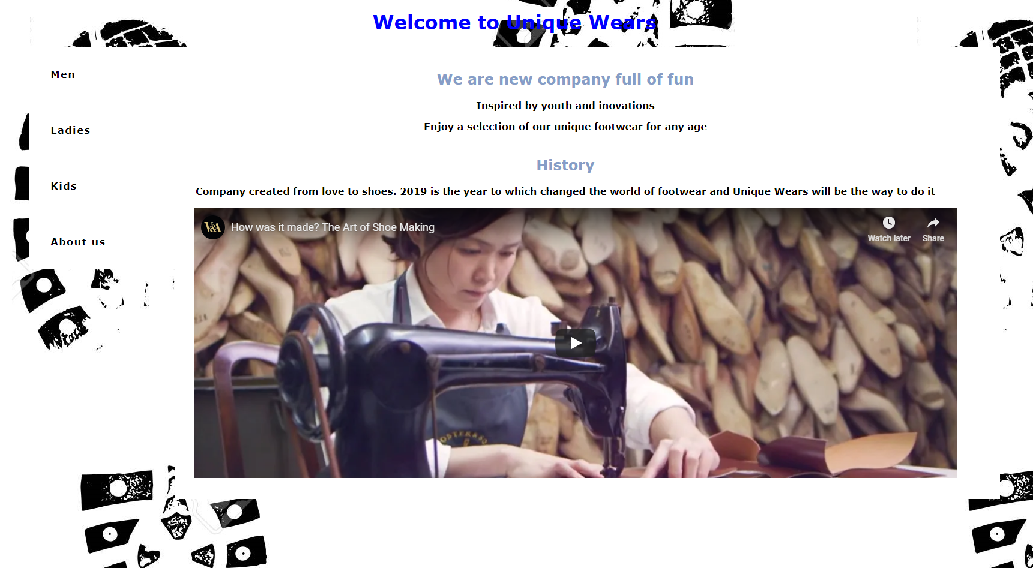

Image 2: Actual look on larger screens

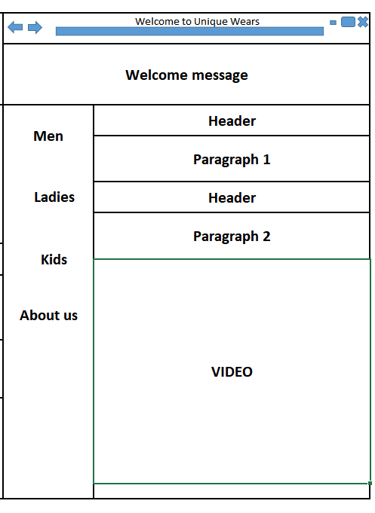

Image 3: Home page sketch design for Mobile displays

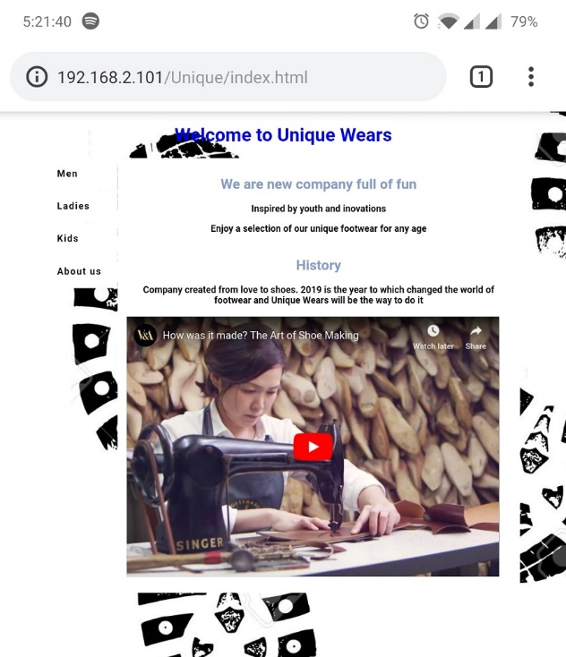

Image 4: Home page Mobile view

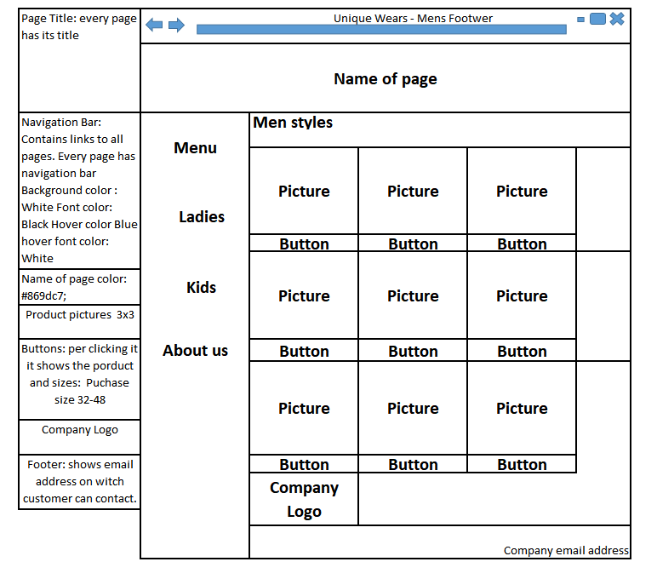

Image 3: Men’s page sketch design for larger displays

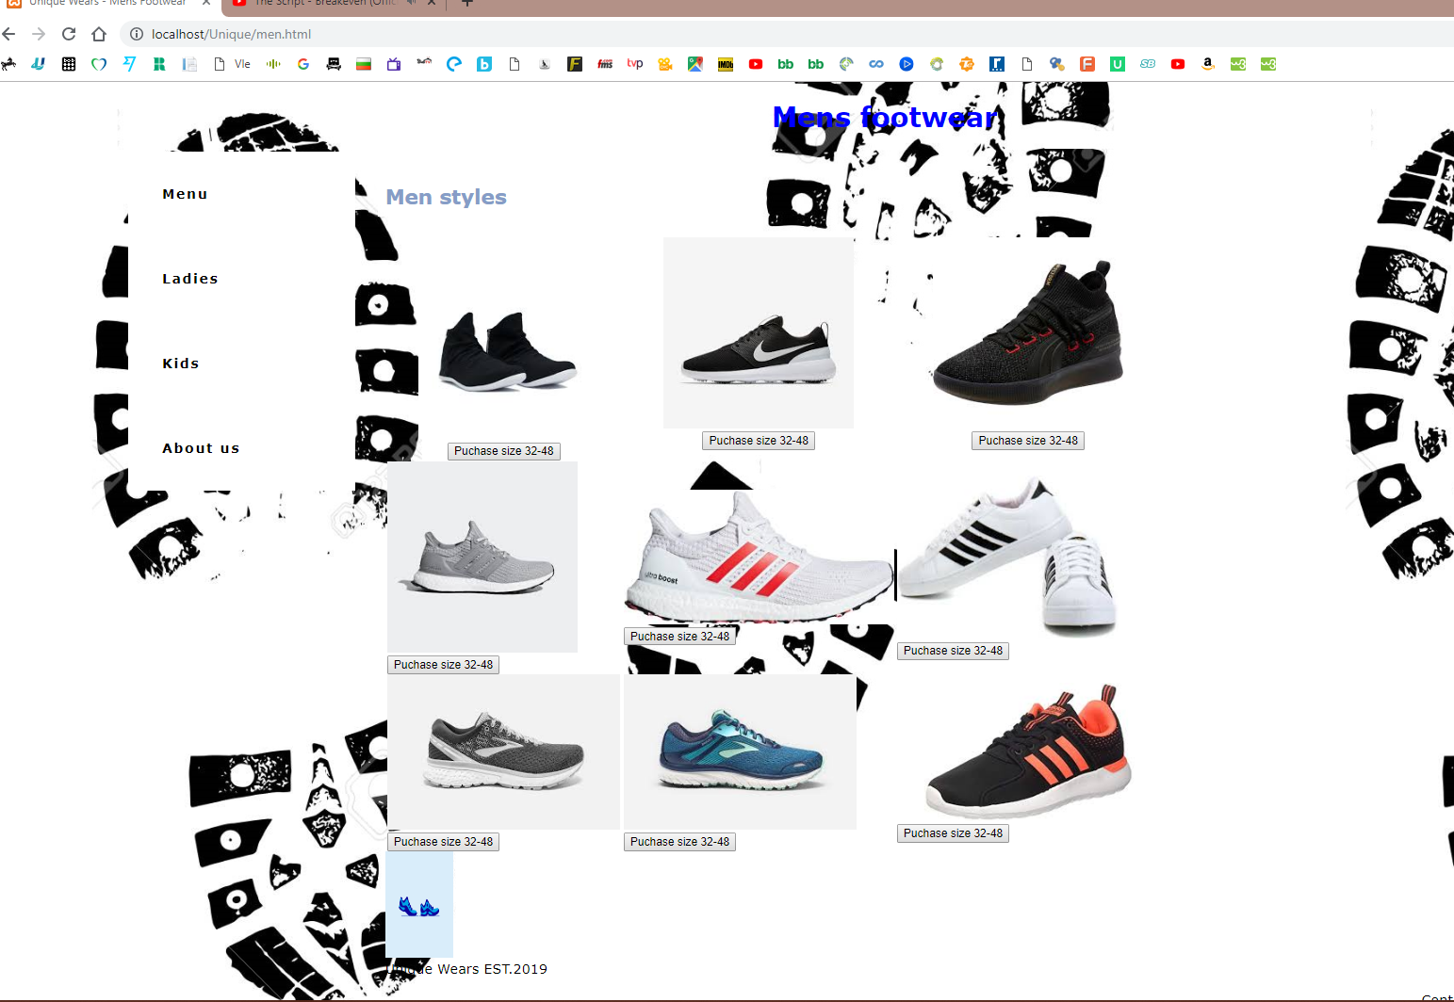

Image 4: Actual look on larger screens

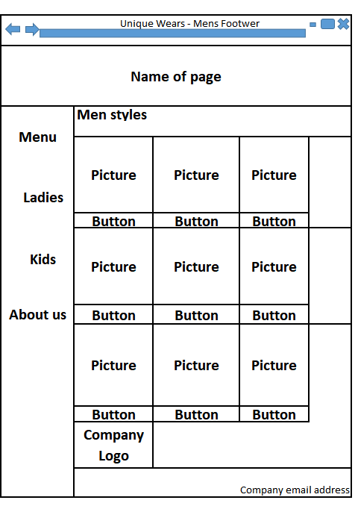

Image 5: Men’s page sketch design mobile view

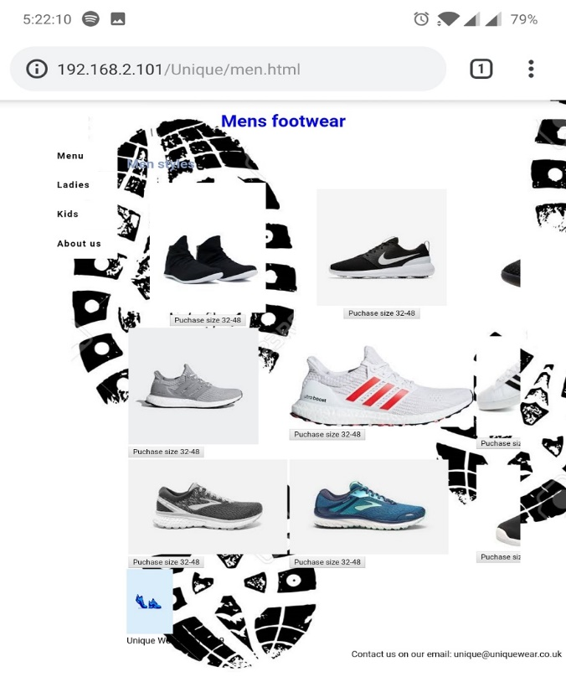

Image 6: Men’s Page Mobile View

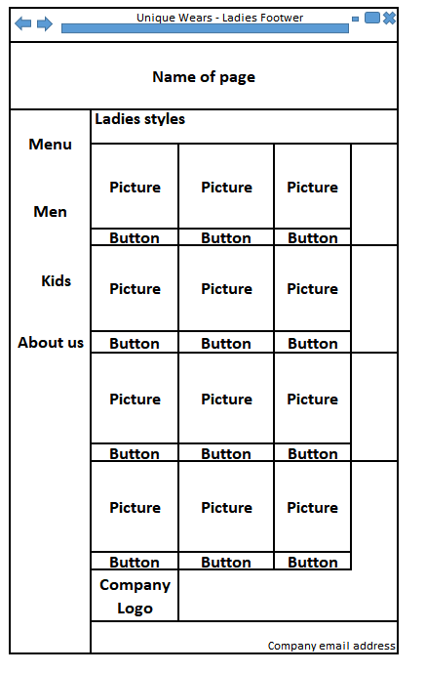

Image 7: Ladies page sketch design for larger displays

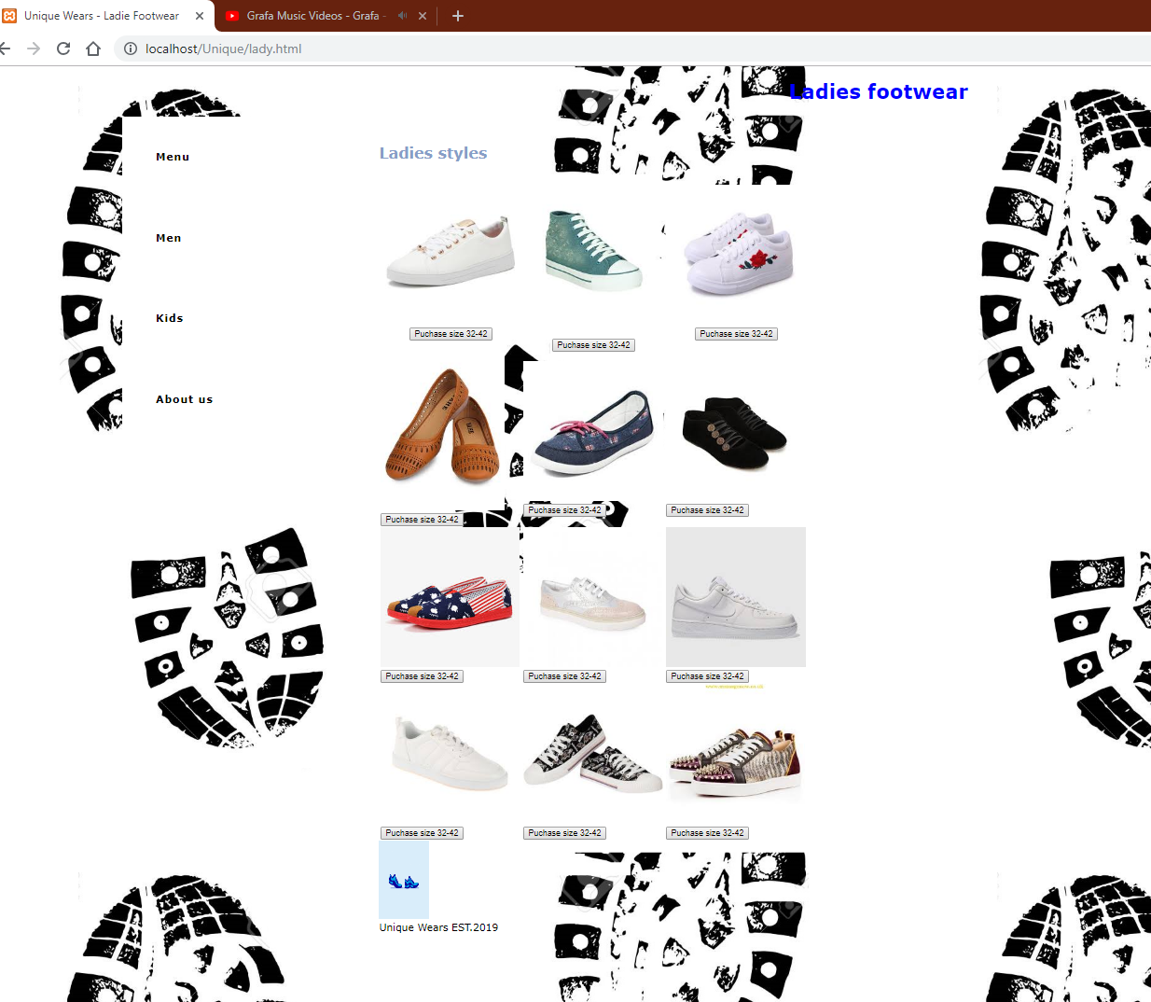

Image 8: Actual look on larger screens



Image 8: Ladies page sketch design mobile view

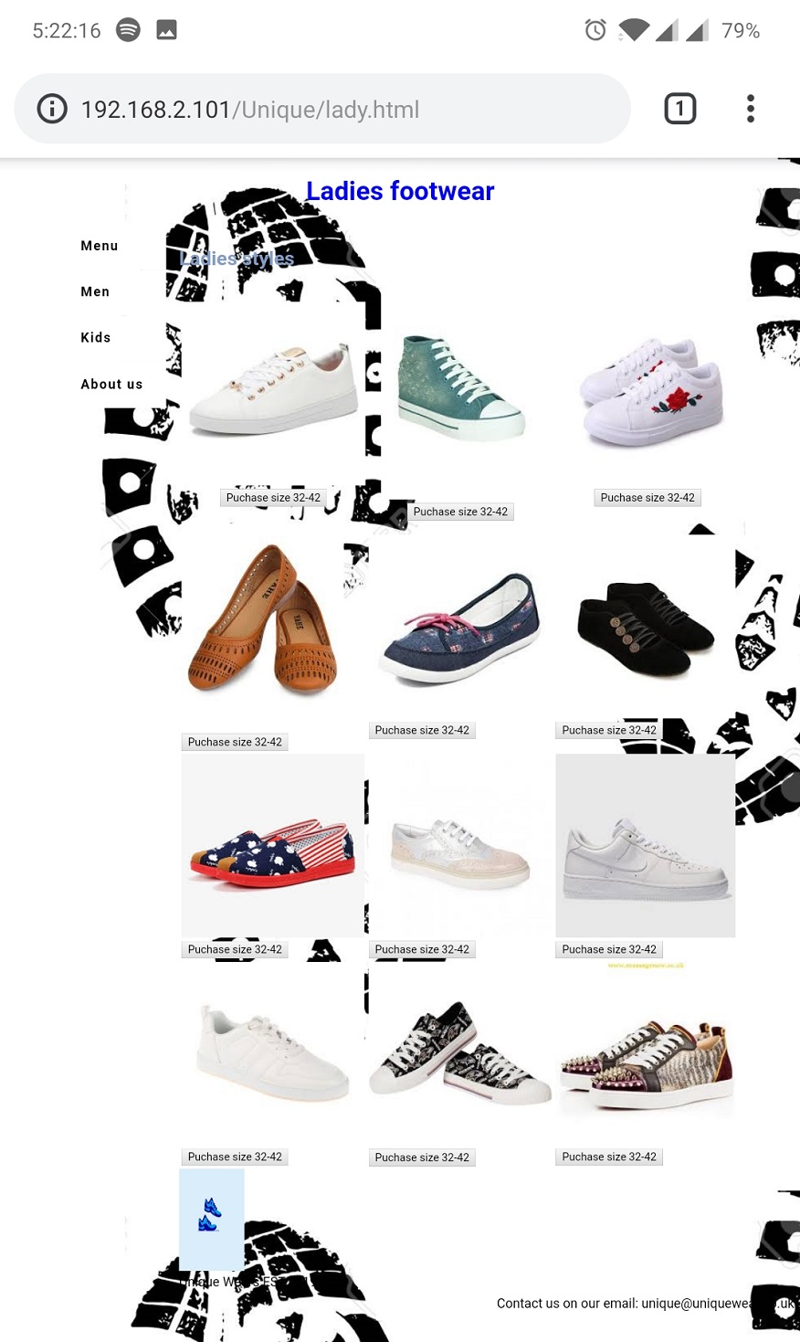

Image 9: Ladies Page Mobile View

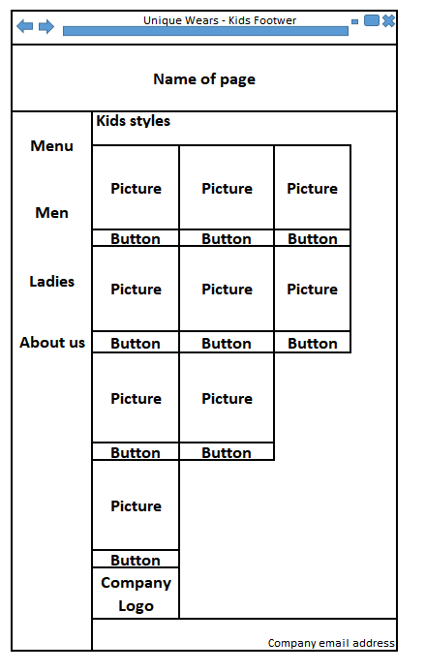

Image 10: Kid’s page sketch design for larger displays

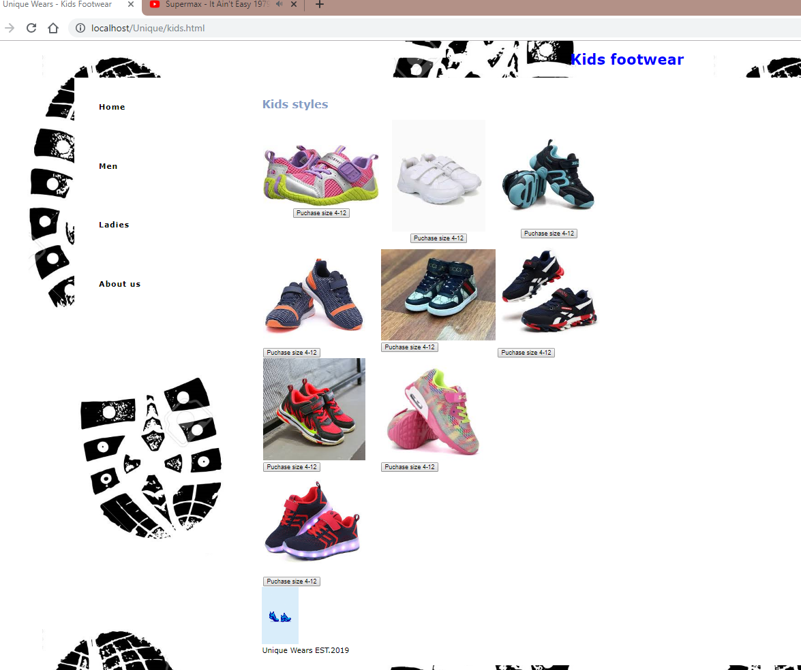

Image 11: Actual look on larger screens

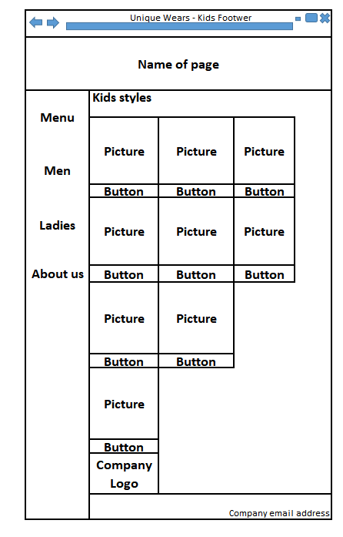

Image 12: Kids page sketch design mobile view

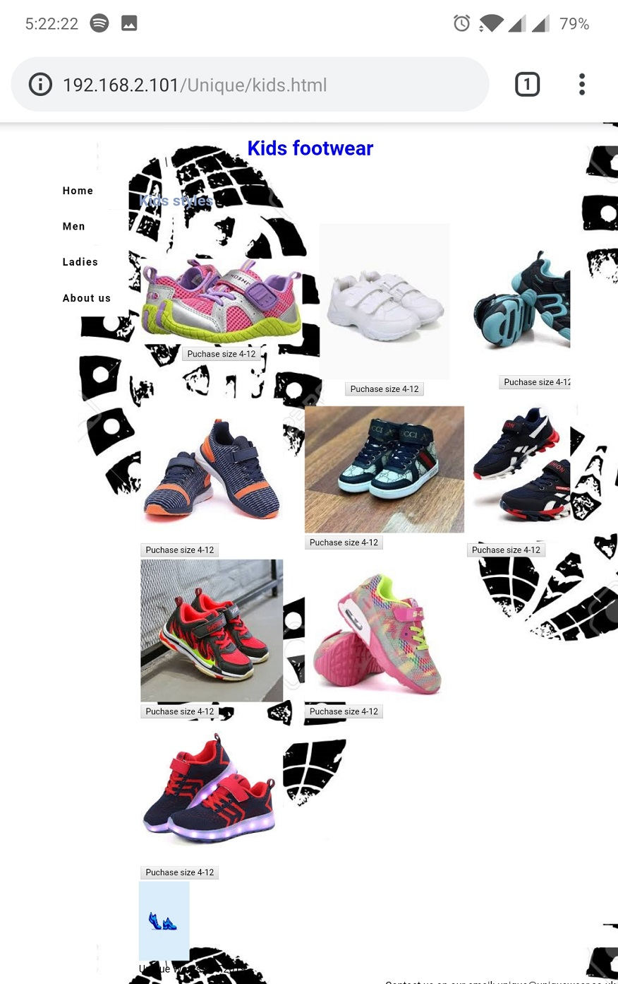

Image 13: Kids Page Mobile View

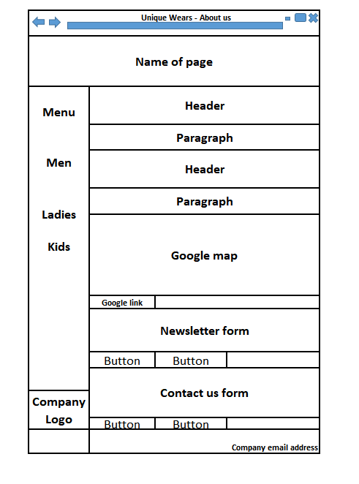

Image 14: About page sketch design for larger displays

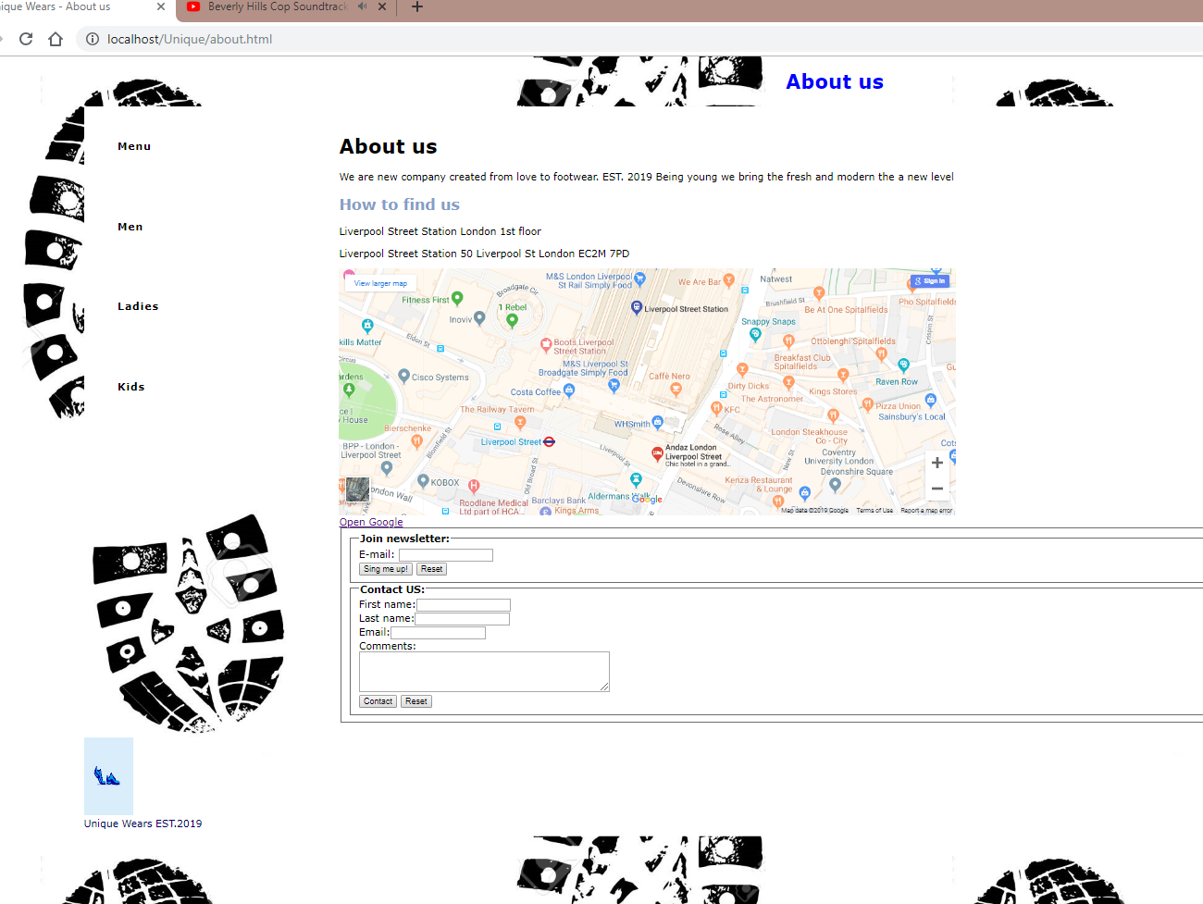

Image 15: Actual look on larger screens

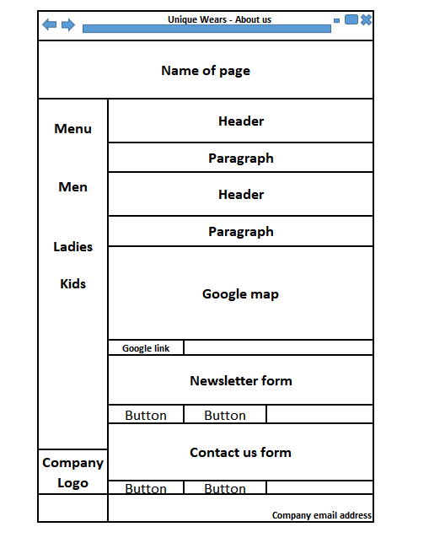

Image 16: About page sketch design mobile view

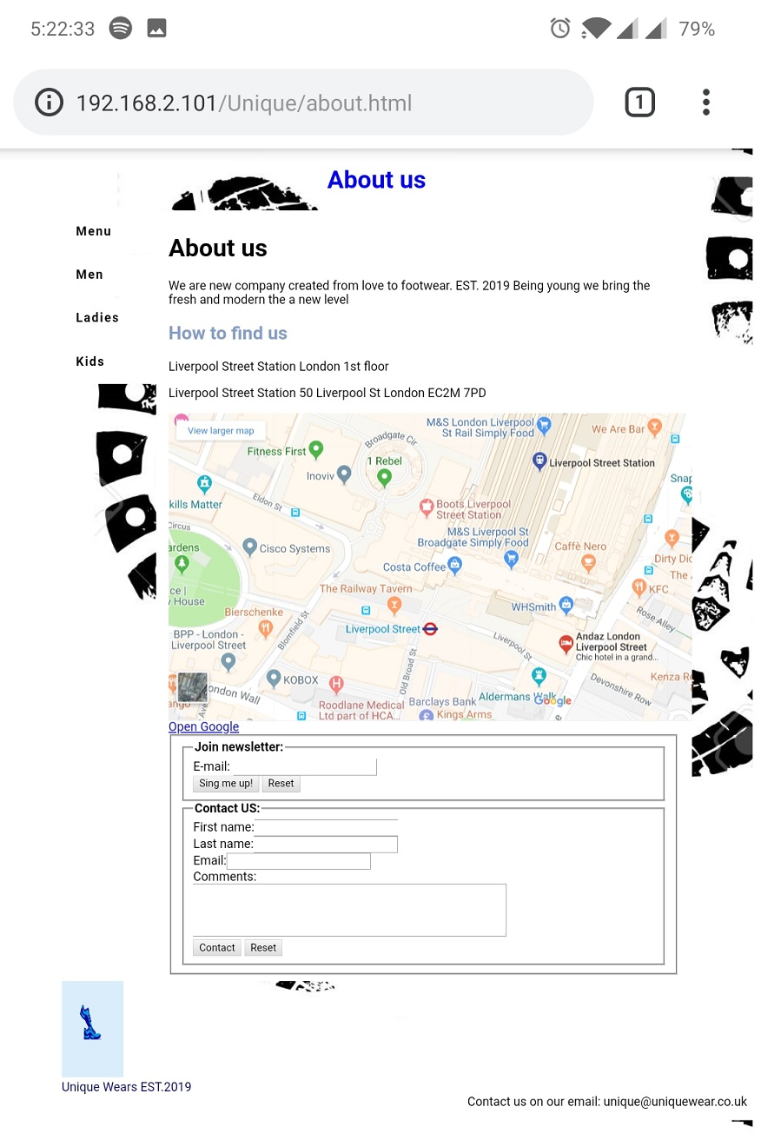

Image 16: Kids Page Mobile View

HTML validation and browser compatibility

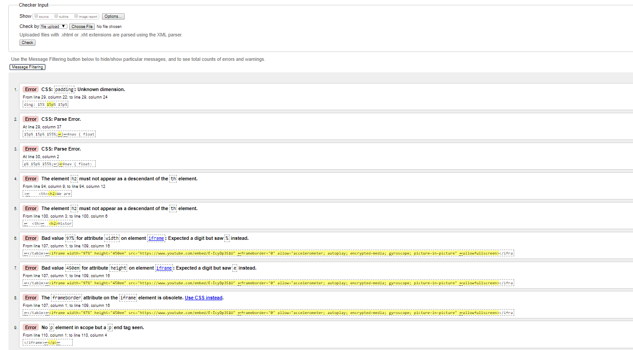

Image 17: Index page HTML Validation

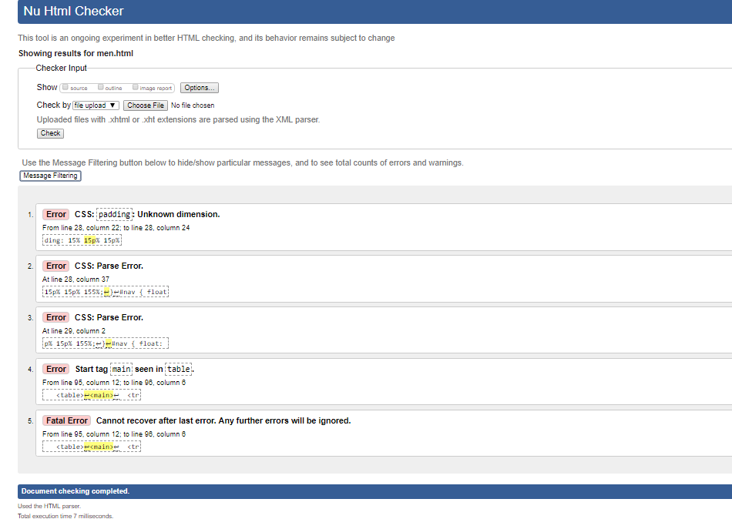

Image 18: Men page HTML Validation

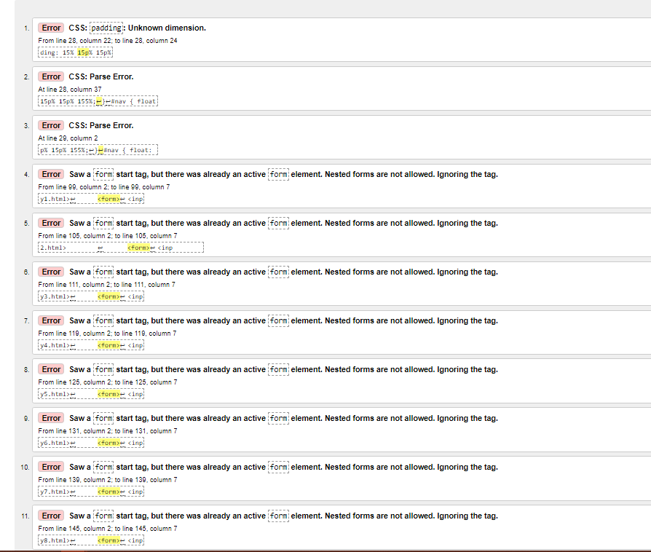

Image 19: Ladies page HTML Validation

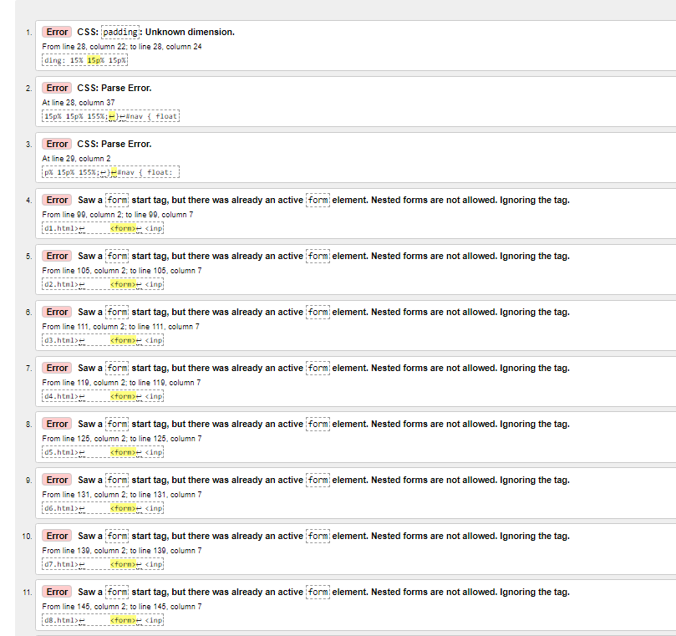

Image 20: Kids page HTML Validation

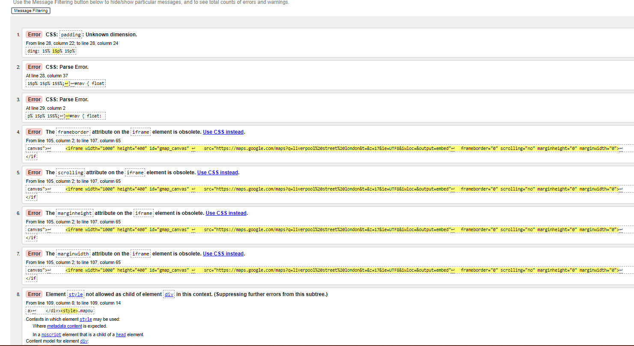

Image 21: About us page HTML Validation

**Browser compatibility passed 100%.**

Internet Explorer Google Chrome Google Chrome mobile

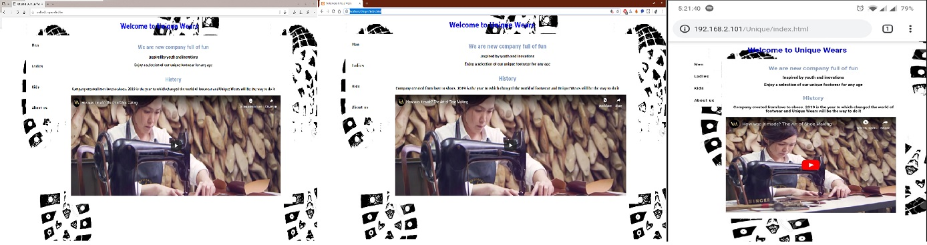

Image 22: Browser compatibility

**Running local server – passed**

XAMPP is most prevailing, free an open source cross-platform which is one solution to run your web services. XAMPP is developed by Apache Friends which released in May 2002. XAMPP Stands for Cross Platform(X), Apache(A), MySQL(M) also Sometimes (M) refers to MariaDB, PHP(P) and Pearl(P).

Where, Cross-platform means it available for multiple operating systems like, windows, Linux and MacOS.

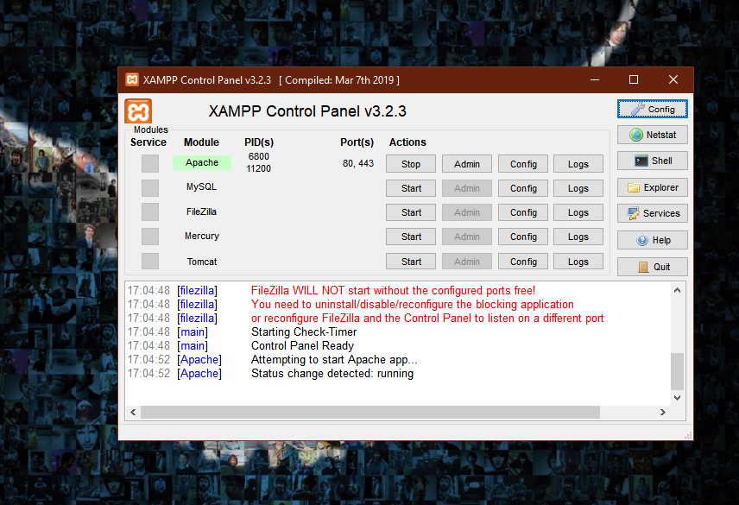

Image 23: Running XAMPP Server

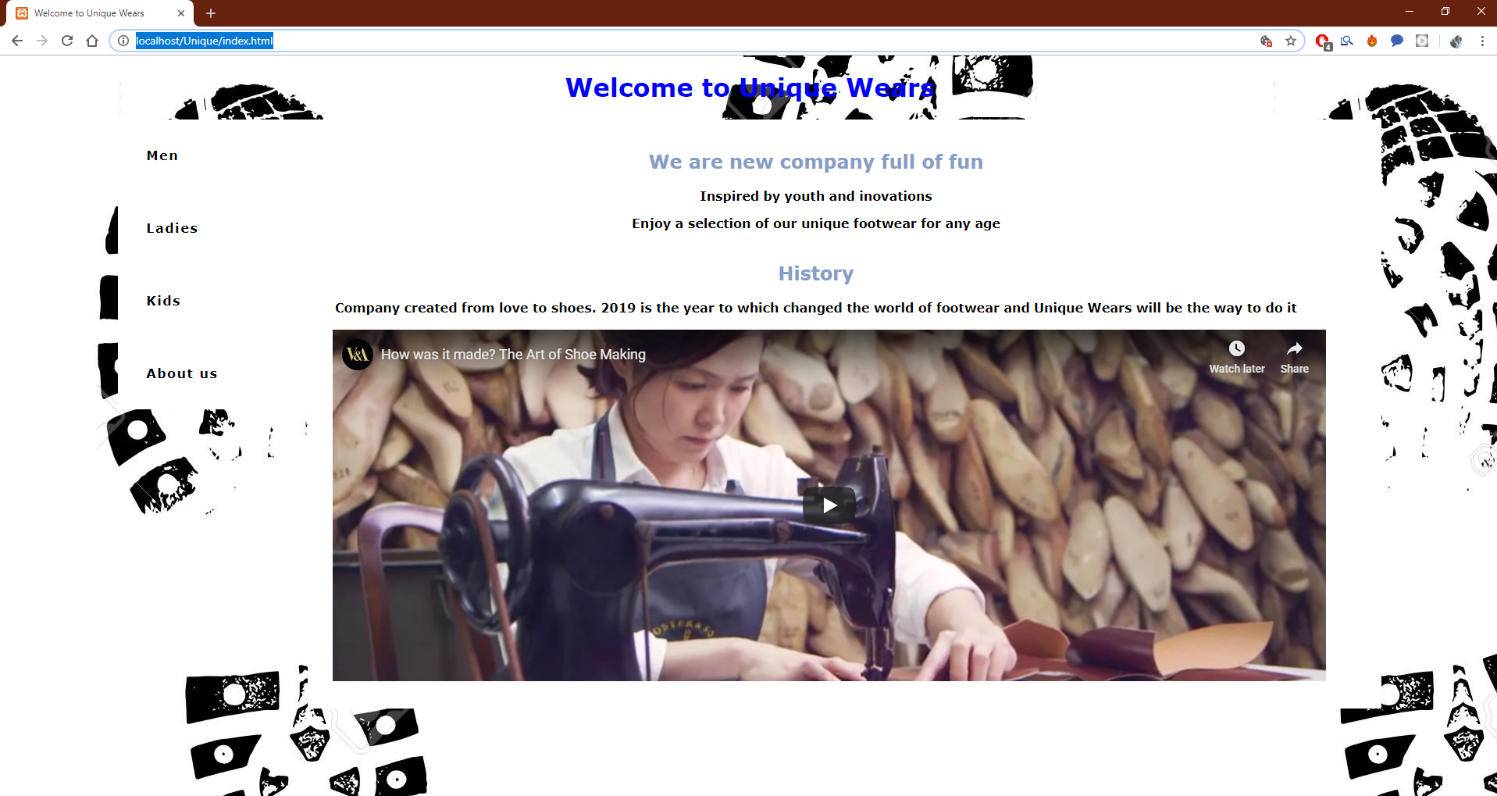

Image 24: Running XAMPP Server on larger screens

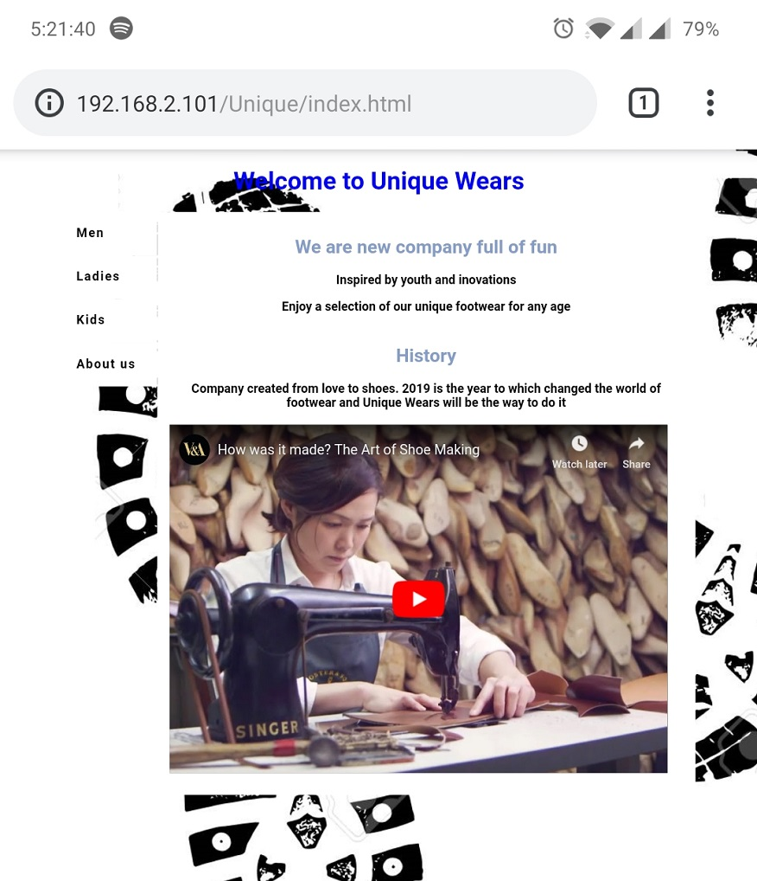

Image 25: Running XAMPP Server on mobile devise

**Appendix**

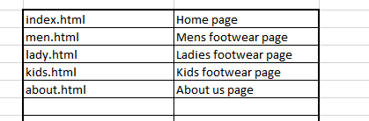



**Reference list:**

* HTML

<https://en.wikipedia.org/wiki/HTML>

* HTML Colour Picker

<https://www.w3schools.com/colors/colors_picker.asp>

* XAMPP Server

<https://www.quora.com/What-is-the-use-of-XAMPP>;

<https://en.wikipedia.org/wiki/XAMPP>

* Install AXAMPP and configure

<https://www.apachefriends.org/index.html>